**IMPORTANT INFORMATION ABOUT THE PAPER RESULTS:** Users can access all normalized dataset and annotation files of microarray gene expression, RNA-Seq and miRNA-target gene dataset from the link below. User can also Access nine breast cancer related GCNs, nine prostate cancer related GCNs and disease gene lists from the same link. The link consists of four main folder, these are :

* **Breast and Prostate Cancer Datasets and Annotation Files:** It keeps datasets of breast and prostate cancers. It also contains annotation files of datasets.
* **Breast Cancer Networks:** This folder keeps GNCs of breast cancer related microarray gene expression, RNA-Seq and miRNA-target gene datasets.
* **Prostate Cancer Networks:** This folder keeps GNCs of prostate cancer related microarray gene expression, RNA-Seq and miRNA-target gene datasets.
* **Gene List from EnrichR:** It keeps breast and prostate cancer related gene lists that are obtained from EnrichR.

Users can repeat our experimental results using given files. The public accession link is given below :

<https://drive.google.com/drive/folders/1TFNa-GulLkB6sAVOOpRYtWdG_WAa00Ow?fbclid=IwAR1Q3P3h5q3b5KUnIIHLP_PkeawslwiiIjJ74adxE9X87q9KcX7Lce8FbjI>

**GENE CO-EXPRESSION NETWORK INFERENCE AND ASSESSMENT ANALYSIS EXAMPLE CODES**

**Load Libraries:**

* library(“c3net”)
* library(“WGCNA”)
* library(“minet”)
* library(“GAnet”)
* library(“ProNet”)
* library(“gProfileR”)
* library(“GNIAP”)

1-) Import dataset. ( microarray gene expression, RNA-Seq, miRNA or other datasets). Example data set is given Figure 1.

* data(dataset) (1)

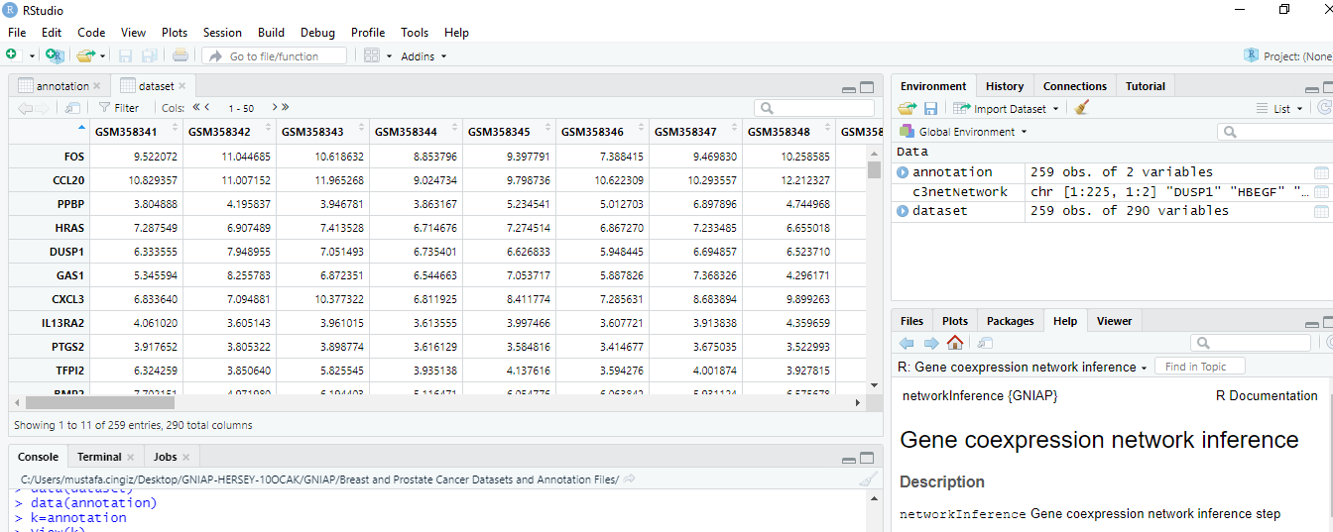

Figure 1. Dataset file for network inference

2-) Import annotation file whose sample is given Figure 1. Annotation file must consist of two columns first probe name and second is the gene name of probe. The important issue is about miRNA-target gene dataset which we obtained from ARNetMiT. This data contains only one colum format annotation file. Thus, we obtained GCNs by using ARNetMiT.

* data(annotation) (2)

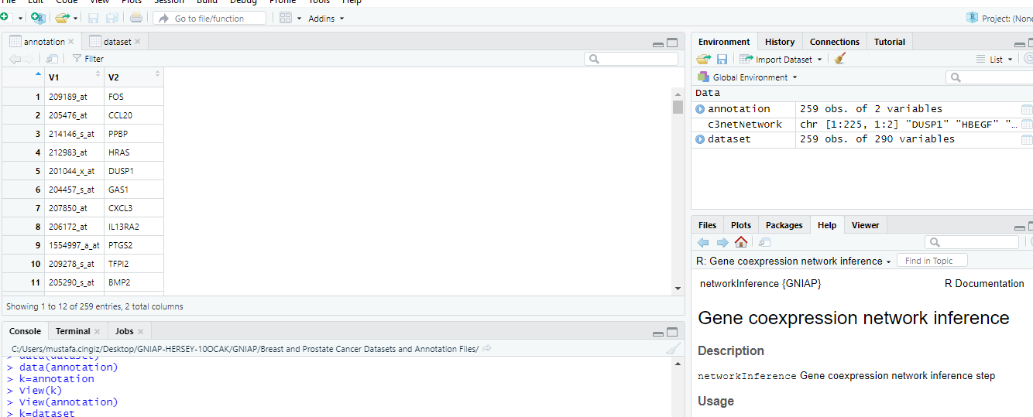

Figure 2. Annotation file for network inference

3-) Apply gene network inference algorithm using “networkInference.R” file. The parameter of “gnimethod” must be one of these: “c3net” ,”aracne” or “wgcna”. Users also select other algorithms “clr” and “mrnet” whose results was not represented in our study. Gene co-expression network (GCN) can be described as binary relations. GNIAP R package infers GCN as given Figure 3 via C3NET algorithm. We apply Code 3 to infer C3NET based GCN. We can also apply Code 4 and Code 5 for ARACNE based GCN and WGCNA based GCN but we only apply Code 3.

* c3netNetwork <- networkInference(dataset,annotation,gnimethod="c3net") (3)
* aracneNetwork <- networkInference(dataset,annotation,gnimethod="aracne") (4)
* wgcnaNetwork <- networkInference(dataset,annotation,gnimethod="wgcna") (5)

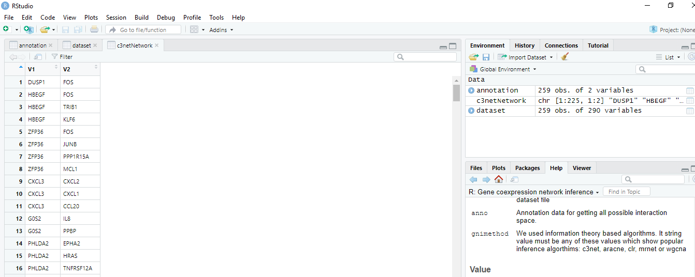

Figure 3. C3NET based GCN after applying Code 3

4-) In overlap analysis, we must load protein- protein interaction dataset which is given in GNIAP R package as “ppi”. The annotation file is also necessart for Fisher Exact Annotation file and inferred GCN is already was retrieved in Step 2 and Step 3. Figure 4 displays the results of overlap analysis which is explained with details in manuscript. We can see True Positive, False Positive, False Negative, p-value of Fisher Exact Test, Recall, Precision and F-Measure values.

Then we apply

* data(“ppi”) (6)
* overlapAnalysisResultc3net <- literatureOverlapAnalysis(ppi,annotation,c3netNetwork) (7)
* overlapAnalysisResultc3net

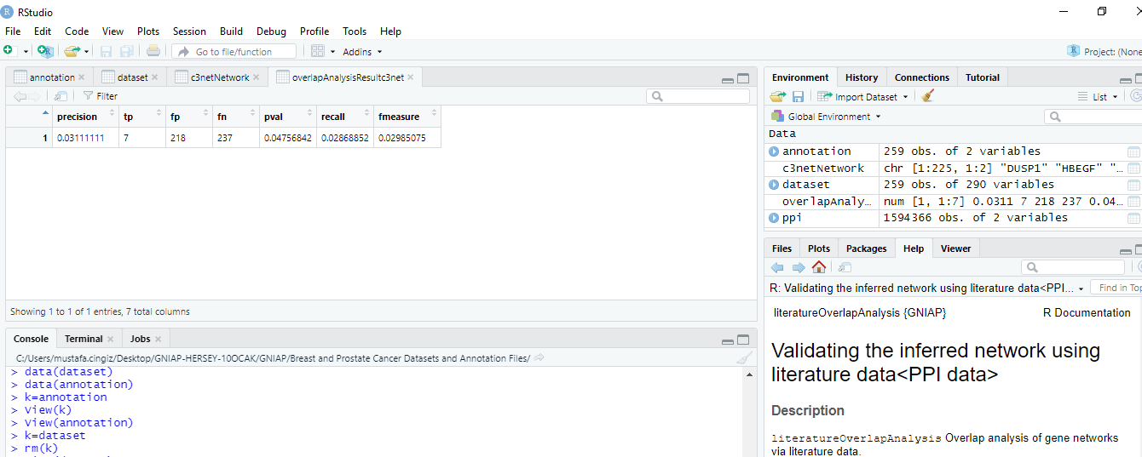

Figure 4. Literature data based Overlap Analysis of C3NET based GCN (after applying Code 7)

5-) In topological assessment part, we used “calculateTopologicalFitness.R” file which call “calculateRSquare.R” file to calculate R2 statistic. calculateTopologicalFitness function also presents Kolmogorov-Smirnov Goodness statistics. Figure 5 presents the topological assessment of C3NET based GCN.

* topologyFitnessValues <- calculateTopologicalFitness(c3netNetwork) (8)

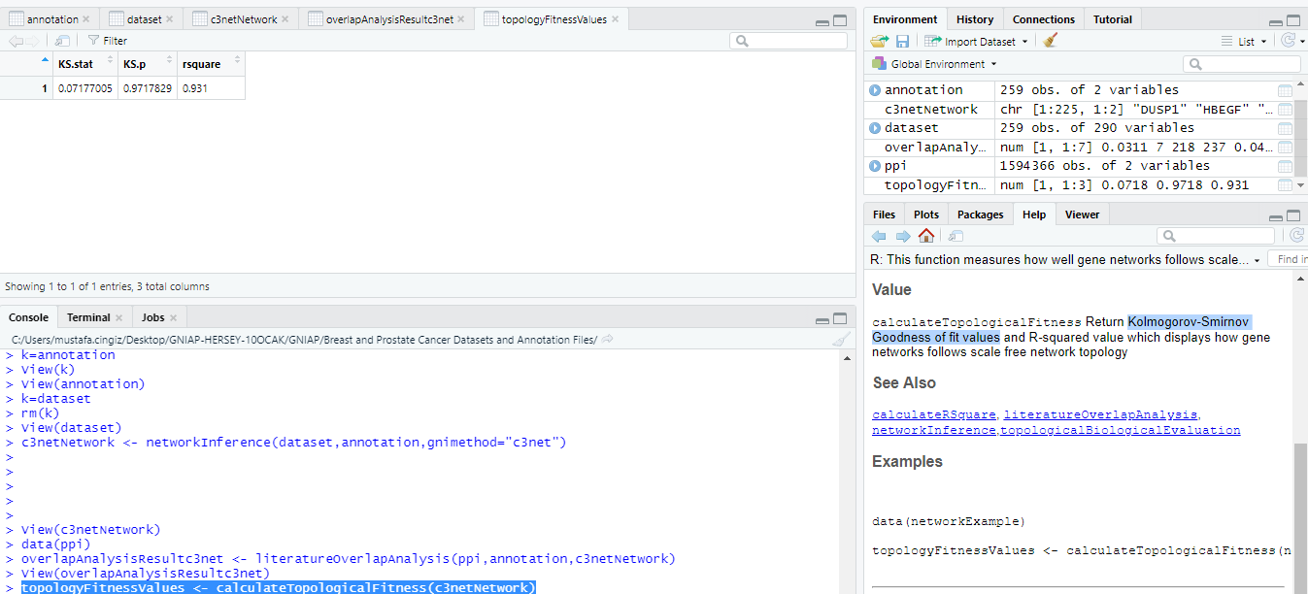

Figure 5. Topological assessment of C3NET based GCN (after applying Code 8)

6-) The last GNC analysis part is the biological assessment. GCNs are divided into modules using MCODE algorithm. GNIAP R package needs the disease related gene list which keeps genes in only one column (Figure 6). Details of biological assessment is described in our paper with details. Figure 7 displays the results of biological assessment of GCN. Figure 7 shows that only one modüle is related to breast cancer in biological assessment overlap analyis. There is no overlapped GO-terms between disease related GO-terms (derived from OMIM gene list) and GCN modules. NaN and zero values displays this situation.

**Important:** topologicalBiologicalEvaluation function takes normalized dataset that we introduce in code 1. It does not contain binary relations that is derived as c3netNetwork.

* data(omim) (9)

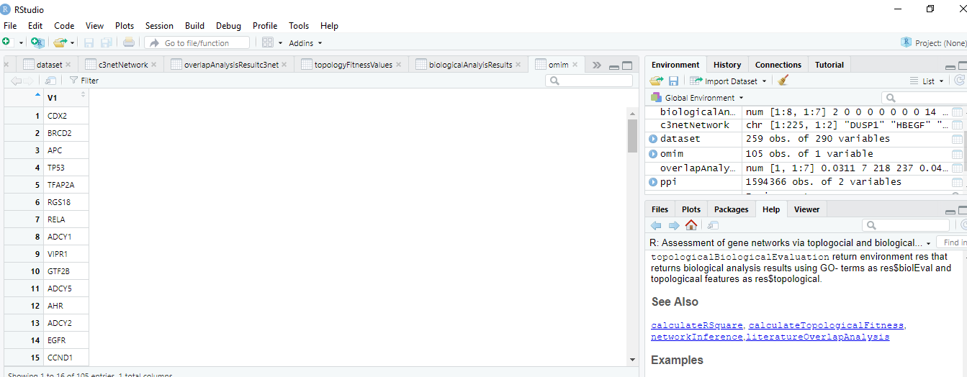

Figure 6. Disease Related Gene List

* res <- topologicalBiologicalEvaluation(dataset,omim) (10)
* biologicalAnalyisResults=res$biolEval (11)

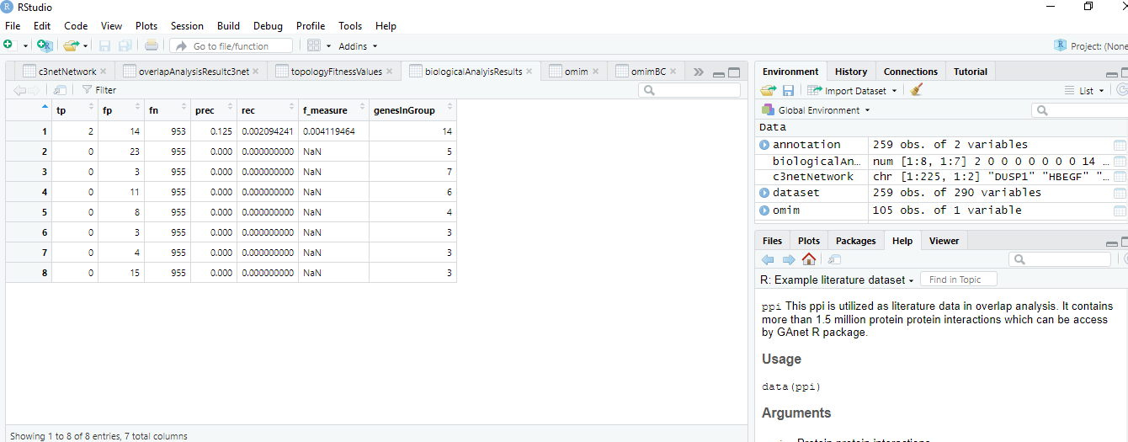

Figure 7. Biological Assessment of GCN